EVERY DAY COUNTS
- volunteering project -
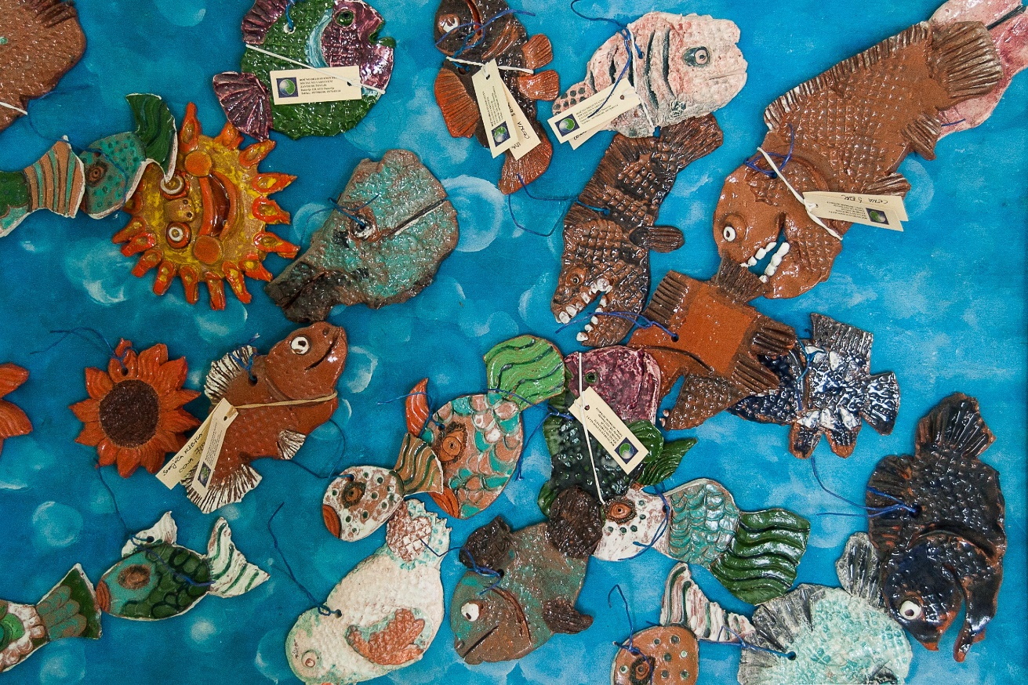
INFOPACK
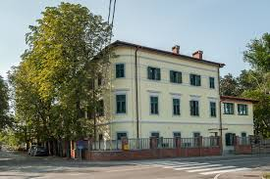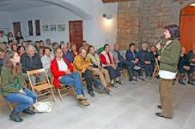

GENERAL INTRO TO THE PROJECT “EVERY DAY COUNTS”
OUR ORGANISATION
Dom na Krasu is a public institution. Established to improve the quality of life for people affected by
mental illness. It provides institutional care for adults with mental health problem.

We’re one of the largest providers of accommodations in Slovenia for people who are not able to live independent life due their mental illness.

Dom na Krasu operates in different locations. We offer services to more than one hundred residents in main building in Dutovlje. Where work differs from dislocated units in Postojna and Sežana where life is organized in a such a way that residents experience normal way of life in order to preserve and gain new knowledge and skills and to be encouraged to take responsibility for their life choices and decisions.

In dislocated units activities are based primarily on improving the quality of life, its their home.
In Dutovlje life of residents in institution looks more hard and difficult but employees and volunteers with their activities rise quality of daily routine.

Our Vision is that we work towards a society that values everyone with mental health problems and making recovery possilble.
Our goal is to bring more effective professional treatment and compassionate care to everyone affected by mental illness.
We believe that our work is deeply valuable and important. We can honestly see the integrity of the work and the value that it has for people who need support.

VOLUNTEERING PROJECT in slovenia

LONG TERM ACTIVITY – 12 MONTHS
From 1st January 2020 till 31th December 2020
Volunteers from Cyprus, Estonia, Spain, Greece, Italy….
2 volunteers

Our project will support two volunteers. They will carry out their activities in the home building in Dutovlje and in the dislocated unit in Postojna.
We summarize their tasks in five points:
1. Carrying out workshops for residents - creative workshops, discussion groups, conducting foreign language courses and etc.,
2. Socializing with users, playing social games, short walks, sports activities ...
3. Participation in events - organizing sport events, celebrations, various campaigns ...
4. Accompaning of users - in everyday tasks (to banks, post offices, shops, escorting to camps and vacations, walks ...)
5. Giving initiatives and conceptual concepts for new, different and innovative activities related to the knowledge and interest of the volunteer.
In addition to the above written tasks, they will disseminate information about their activities and European Solidarity Corps.
We want to host volunteers who are motivated to work with people with mental health problems. We welcome participants with diverse skills and who are looking forward to share their creativity through music, creative workshops, languages, computing, sports, photography, etc. We expect a volunteer to have an emphatic attitude and to be personally mature.
Volunteer will sign activity agreement where all responsibilites and rights will be listed.
AVANUE of volunteering service
POSTOJNA
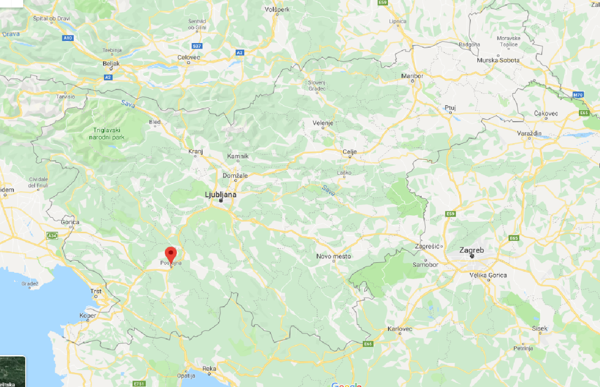
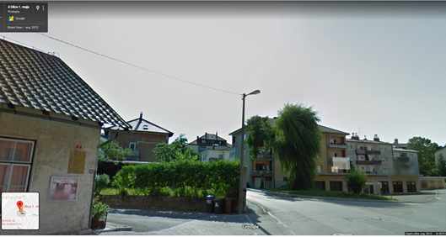
Postojna - 2 apartments where eleven people live

DUTOVLJE
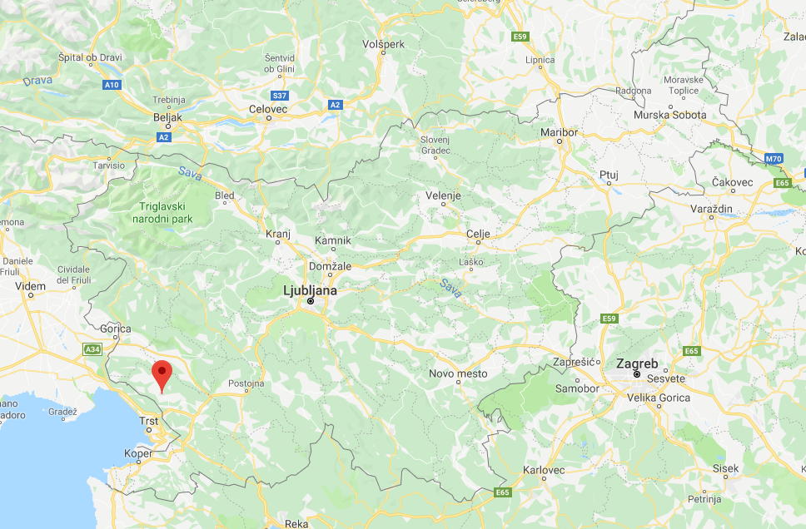

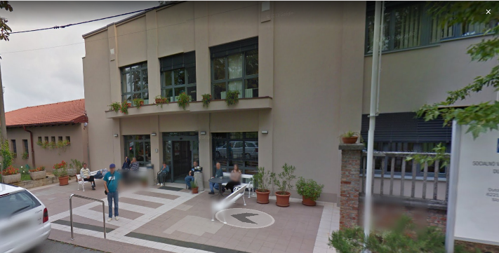
Dutovlje – main building where more than 80 residents live

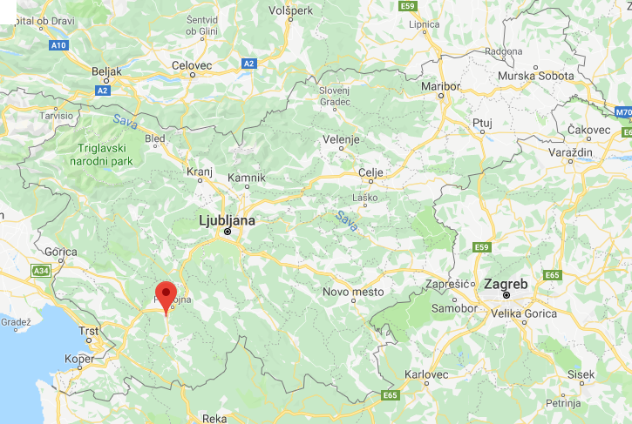
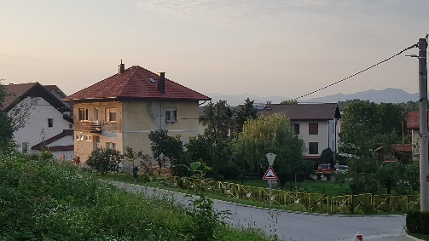 VENUE AND ACCOMMODATION – PRESTRANEK

Living in house with other volunteers, sharing room, bathroom and kitchen.
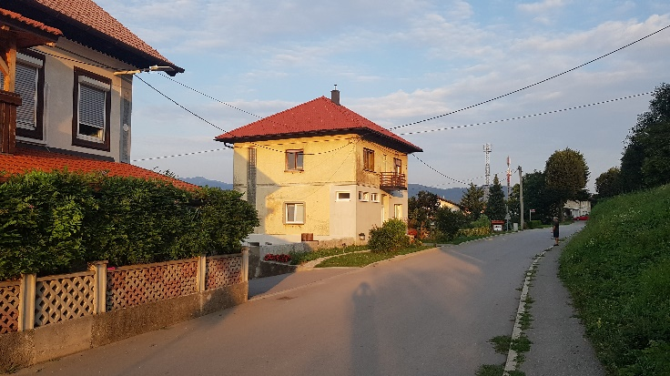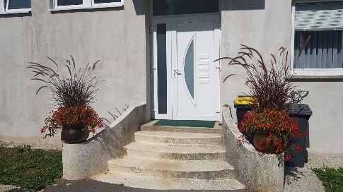

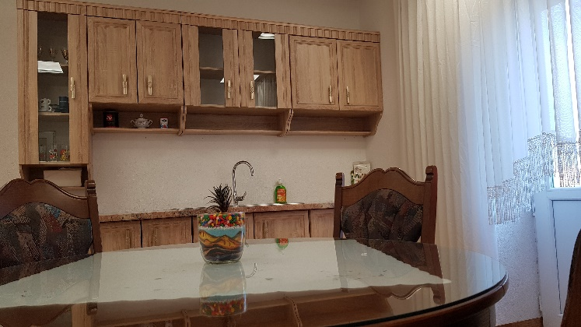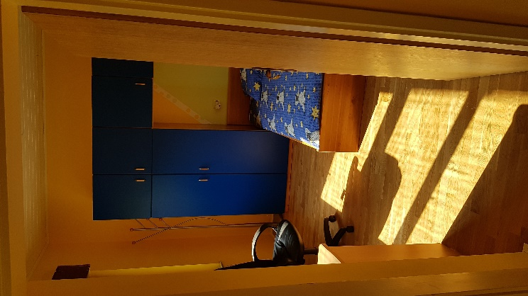
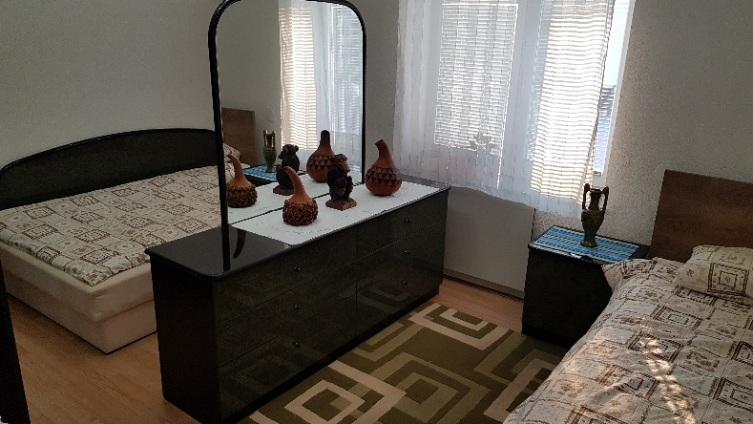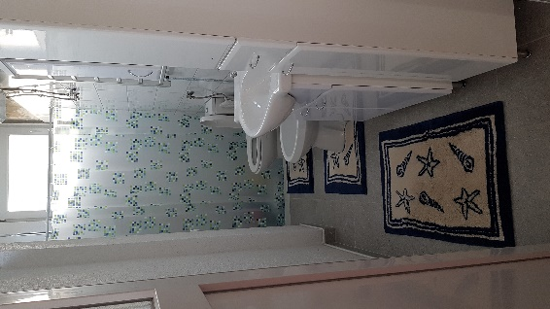
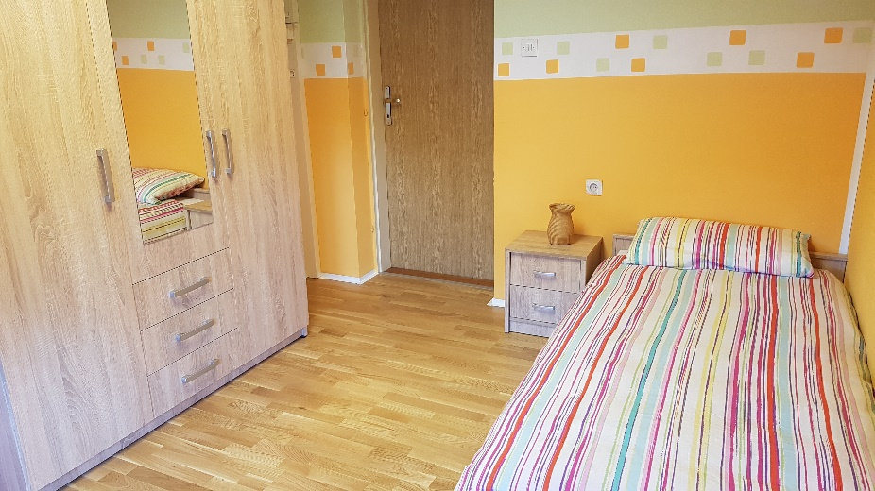

WORKING HOURS
Daily activities cover 30/36 hours per week and include:
1. Carrying out workshops for residents - creative workshops, discussion groups, conducting foreign
language courses and etc.,
2. Socializing with users, playing social games, short walks, sports activities ...
3. Participation in events - organizing sport events, celebrations, various campaigns ..
4. Accompaning of users - in everyday tasks (to post offices, shops, escorting to camps and
vacations, walks ...)
5. Giving initiatives and conceptual concepts for new, different and innovative activities related to the knowledge and interest of the volunteer.

Volunteers have 2 free days per week, normally Saturday and Sunday. The ESC volunteer has 2 extra days off per month.

POCKET and FOOD MONEY
The pocket money is calculated on the ESC - European Solidarity Corps programme, which amounts, in the case of Slovenia, to € 4 / daily. The food money volunteer will receive once per month in their account, at amount € 180/ month.

LANGUAGE SKILLS
Online linguistic assessment and language courses in Slovenian will be available via the Online Linguistic Support (OLS). The volunteer will also have the opportunity to practise additional anguages through community and learning activities promoted by the host organisation, which take place on a weekly basis.

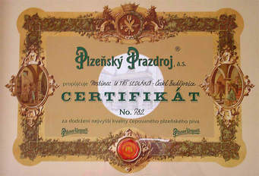 YOUTHPASS CERTIFICATE
All volunteers in the European Solidarity Corps programme are eligible for Youthpass Certificate,
a Europe-wide tool to document and recognise learning outcomes from youth work and solidarity activities. It is a part of the European Commission’s strategy to foster the recognition of non-formal
learning, putting policy into practice and practice into policy.

FREE TIME ACTIVITIES
Volunteers can also organise their own free time activities, and local staff will be very willing to offer assistance or suggestions.

HOW TO GET HERE
The journey from each volunteer’s home city to Postojna will be organised by the partner organisation in cooperation with hosting organisation.

LOCAL TRAINS: Prestranek regional train stop at Postojna train station (6,3 km / 12 min) – travel cost cover by project

LOCAL / NATIONAL BUSES: Prestranek regional bus/train stop at Postojna bus/train station. From Postojna to Dutovlje is 40 km, one hour drive by train.

CONTACT :
http://www.domnakrasu.si

Dragana Kosić Petrović – coordinator
dragana@mcp.si
https://www.facebook.com/dragana.k.petrovic
+386 40 798 222
Nataša Seražin
natasa.serazin@domnakrasu.si
+386 744 615

