Grenzenlos_Camp-Season_ 2018
for ST-EVS

GL01 _Vienna_”Äktschn im Park”: 07.07. – 28.07.2018
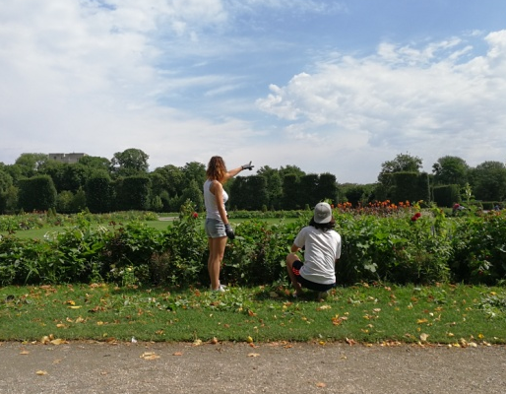
ENV/REN/DIS 10 VOLS (18- no upper age limit)

Location: The International Camp will take place in a public park in Vienna from 7th to the 28th of July 2018.

Work: We will mostly work with the Vienna gardeners in the green areas of this famous public park called “Augarten”. We will as well do some cleaning, renovation and some painting work of the facilities, walls and benches. The Augarten is located in the centre of Vienna (2nd district). The work will start on Monday 9th of July. We will work five days a week, six hours with a lunch break of an hour, from 9:00-15:00. Moreover, we strive to include 1-2 local participants with fewer opportunities either in the work or in free time activities. We want to offer them the possibility to get to know people from all over the world. In this way we want to set an example and promote of integration of people with disabilities in this working area. At the end of the international camp we will organize a farewell barbecue/get together.

Accommodation: We will be hosted in a youth centre in Vienna: “5er Haus”. Things to bring with you: You need to bring with you a sleeping bag and a sleeping mat (we will sleep on the floor), working clothes, working shoes, raincoat, swimming suit, sun protection. If you require any medications (e.g. because of an allergy), don’t forget to bring them with you.

Food: We will cook for ourselves, mostly vegetarian. (Please inform us whether you require a special diet). Your accommodation and food are covered – however, we recommend you to bring some pocket money: the currency used in Austria is Euros. Furthermore we invite you to bring typical food, spices, drinks, games and music from your country (for an intercultural evening) – and a lot of motivation!

Insurance: During the international camp we will only have insurance for accidents. Nevertheless, you need a full insurance (medical) for your travel and the time in Austria; don’t forget to arrange your insurance prior to your departure!

Contact person: Carlos Gauna:
camphosting@grenzenlos.or.at

GL04_Vienna_”Let’s Act”: 29.07. – 19.08.2018
ARTS/DISA 15 VOLS (18- no upper age limit)

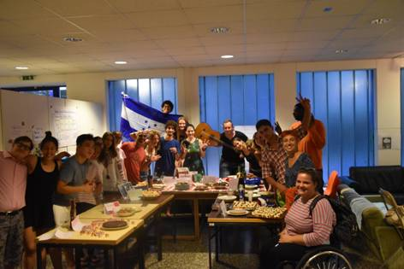
Location: The international camp will take place in Vienna from 29th of July – 19th of August 2018.

Work: The main focus is to create our own short theatre play and experience how much fun acting, dancing and playing can be in a group of great variety. We will include young (international and national) people with fewer opportunities and have the support of professional theatre pedagogues, who will teach us exercises and give us instructions. The theatre sessions include the recognition and use of natural tools (body, voice, and space) and the development of potential skills (concentration, imagination, memory, expression, and creativity). You will be involved in a dynamic theatrical process and at the end of the camp, we will perform your self-created play.
There is no need for any theatrical knowledge in advance, but your motivation and willingness for acting is important because the theatre sessions are creative and artistic practices and your input is needed.

Accommodation: We will be hosted in a youth center in Vienna: “5er Haus”. Things to bring with you: You need to bring with you a sleeping bag and mats (we will sleep on the floor), comfortable/ sports clothes for the theatre activities, working shoes, raincoat, swimming suit, sun protection. If you require any medicaments (e.g. because of an allergy), don’t forget to bring them with you.

Food: We will cook for ourselves. Please inform us whether you require a special diet or are vegetarian. Your accommodation and food are covered – however, we recommend you to bring some pocket money: The currency used in Austria is Euros. Furthermore, we invite you to bring typical food, spices, drinks, games, and music from your country (for an intercultural evening) – and a lot of motivation!

Contact person: Carlos Gauna:
camphosting@grenzenlos.or.at

