Earth Wind and Fire

The project was born out of the need to work together and build communities. After months locked up at home, social bonds are more than fragile between individuals. Especially in a popular districts such as that of "Carpentino" in Altamura, where people already live various social and economic problems.

The main idea is the construction of a clay oven that will bring a new service to the community in the “Bosco-Fiore” the garden of the Community Library “Agorateca”. The oven will be built with special techniques and become a central point of sociality for the neighborhood and for all the young people of the city, around the preparation and sharing of a meal.

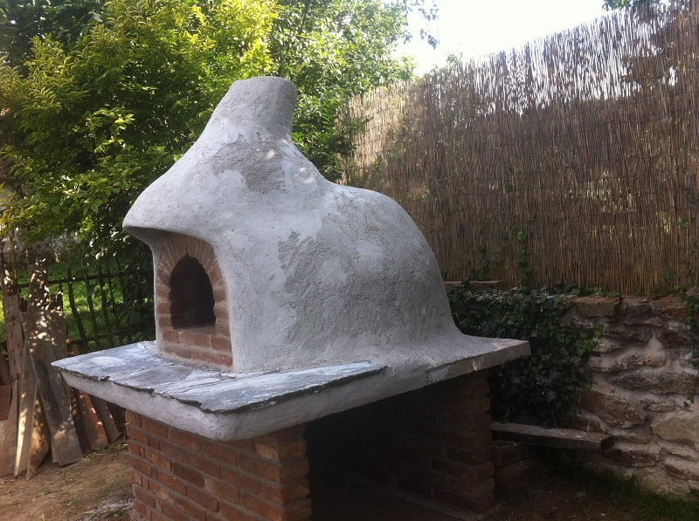

AIMS

- To let a group of young people, from different nationalities, experience the collective creation of an eco-sustainable common good, for the Altamura community. Create collectively, following a common purpose, sharing values ​​of cooperation, common goods and tolerance inspite of cultural differences.
- Raise awareness among young people of their power as citizens, to transform their urban spaces, and strengthen their active participation.
- To increase "empowerment" (the power to act from below) and the feeling of citizenship of every young person and the citizens of Altamura.
-Take an environmental approach using eco-materials and recycled materials, enhancing the “zero” kilometer approach, local resources; putting itself in an "out of the market" logic. T
- To discover eco-sustainable alternatives, for an environmentally friendly future.
- Share manufacturing knowledge, learn ancestral techniques (bread / earth building ...) using raw materials. Young people will be led to open up to local knowledge, founders of the city's culture and to exchange on their own cultures.

THE GROUP
20 young people, 4 nationalities, 4 partners (including Link, the applicant)

DURATION
9 days (included travel days)

WHEN
Spring 2021

WHERE IS IT
The Bosco-Fiore, community garden, next to the Agorateca (community library), ALTAMURA (Italy).

https://www.agorateca.it/giardino-e-orto-urbano

If you are interested, please send your PIF to link@linkyouth.org

