INFOPACK
Youth exchange
18. – 24.07.2022.
(travel dates included)
Šabac, Serbia

About the project

Project “EcoYouth” will gather young people from 5 different countries – Bulgaria, Portugal, Romania, Slovakia and Serbia; who will live, work together and exchange knowledge, skills and attitudes on the topics of ecology and youth activism. They will also share their ideas, culture and customs with young people between each other.

The project aims to empower young people with fewer opportunities to become a responsible, critic, active for environmental issues, and a healthy lifestyle in the local and European communities.

Objectives are:
- To empower young people with fewer opportunities from passive behavior to active participation and taking care of an environmental and healthy lifestyle.
- To support youth advocacy and activism within youth empowerment as an outcome in which youth, as change actors gain the competences
- to impact the own lives and lives of other young people and the communities as a whole;
- To experience multi-culturalism through meeting and working with youngsters coming from different cultural and linguistic backgrounds.
- To become aware of the European community and to use opportunities of Erasmus + program as a tool for the development of the culture of youth participation in environmental activities.

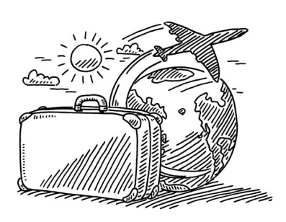
Travel
Nearest airport is in Belgrade, Serbia, but there are possibilities to use airport in Budapest, and we can organize transport from Budapest to Šabac.

If you are coming by plane, please, let us know about your arrival and departure, because we offer you 2 options:
1. to wait for you at the airport and drive to Šabac, or
2. you can go to Belgrade with airport bus and then to come by bus to Šabac
If you are coming by bus: https://www.balkanviator.com/en/

!!!Before planning your trip, please contact us!!!

IMPORTANT NOTICE!

When you are in the bus please send information about time of arrival to this phone number +381-62-641274 (Voja) so that someone can wait you and do not forget to sigh your message to know who to expect.

If you are arriving earlier or leaving later from the exchange dates, you have to take care of the accommodation by yourself on your costs. Before buying the tickets, please contact us.

Covid 19 and traveling
Due to the COVID 19 pandemic there are specific travelling requirements for those arriving to Serbia. Please check more on:
https://www.mfa.gov.rs/en/citizens/travel-serbia/covid-19-entry-requirements

Venue place
Šabac, Serbia
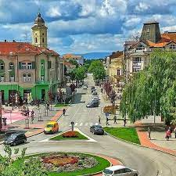
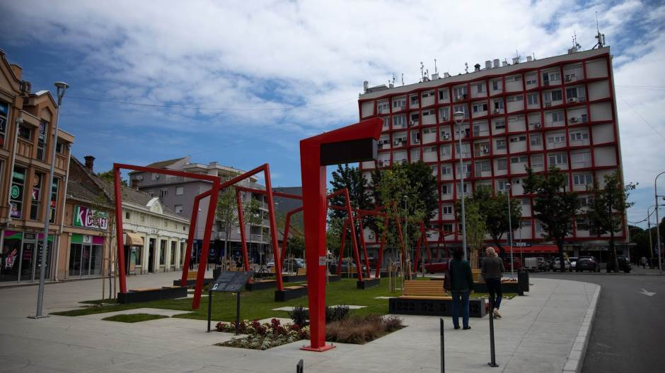
In Serbia, there is one small but famous city named Šabac.

It was and is a place of humor, hospitality, music and lights.

In the past time it was called „Little Paris“ and this place was first for many things.
It is located in Western Serbia, on the right bank of river Sava, around 80 km away from Belgrade, the capital of Serbia. If you want to find more about the city please go to http://sabac.rs/about-sabac.htm

You will be placed in Art of Life, big family house with 4 or 6-bed rooms, where breakfast will be served and where you can spend chill free time with beautiful host family and Chupka (home is dog friendly place)
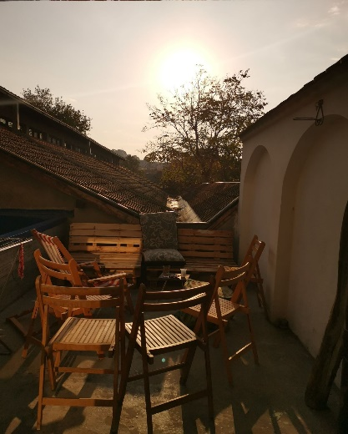
https://www.facebook.com/art.of.life.sabac/
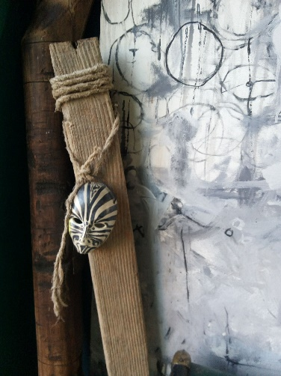
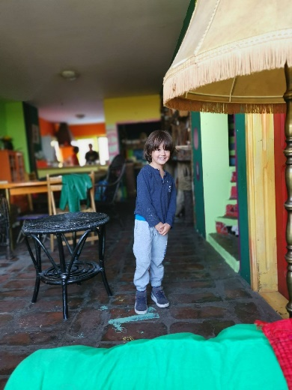

Adress: Milosa Obilica 63.

Šabac is a small and everywhere you go it does not take you more than 15 to 20 minutes on foot.

Please bring your own hygienic set and towels!
Tips & Tricks
- Bring your computer/smartphone/camera if you own one
- Euros can easily be exchanged in exchange offices in Šabac.
1 euro = 117,5 rsd (dinar – Money of Republic of Serbia)
- Check the weather before coming to Sabac, so you can bring right cloths and shoes
About the travel (e.g. delay on planes and connections, lost luggage, you fall in love with the pilot and decide to change your plans, etc.), logistical issues or any emergency please contact Vojislav Radosavljević - Voja - +38162641274 (Viber, WhatsApp)
Alternative phones:
- Gordana Mandić Radosavljević – Goga - +381638289342
- Mirjana Dragojević – Mira - +381693884251

!!!Do not forget to sign your emails and SMSes!!!
Otherwise, we need more time to find out who is sending them.

List of tasks before arriving on Youth Exchange

- Meet your group/youth leader and other people from your group
- Together with your group get prepared for the Intercultural evening and Family dinners (if you do not know what are these please ask your leader or ask us directly)
- Together with the group, you should do Preparatory work for Show&Tell session - find 3 bad and 3 good things related to environmental issues in the community and create presentation in PowerPoint or Prezi.

During the Youth exchange we prepare Code of behavior to be followed by everyone during activity:

- Treat everyone with respect and dignity
- Everyone will have space to express themselves
- Involve all from the group in the decisions that affect them
- Every participant has to be available and fully committed to
take part in the whole duration of the exchange;
- Participants should be curious, open-minded, appreciate
diversity and learn about each other’s realities;
- Participant should be motivated to learn and to apply what
they have learnt.
- 0 (zero) tolerant rule – no use of, drugs, bullying of any form (verbal, nonverbal…), racism or sectarianism of any form, abusive language or gestures, favoritism and exclusion
- all people should be equally supported and encouraged.

 | 18.07. | 19.07. | 20.07. | 21.07. | 22.07. | 23.07. | 24.07.
AM | Arrival of participants/  Registration and accommodation  Introduction to the venue&  technical information | Ice breakers/Name games/Getting to know each other  Introduction, expectations, learning objectives  Ground rules |  | Trip to Nature | Multimedia workshop  Photo/video…what are the elements of democracy, … |  | Travel day  Germans and Italians are leaving
PM |  | Team building activities  Learning diary  Factory of learning |  | Trip to Nature | Youthpass certificates, | Session of final evaluation Closure
EVE | Welcome  dinner | Intercultural evening |  |  | Family dinners? | Farewell party | Arrival in Germany and Italy
Program of the Youth Exchange

Practical workshops: redesign clothes, urban gardening, video and photo

